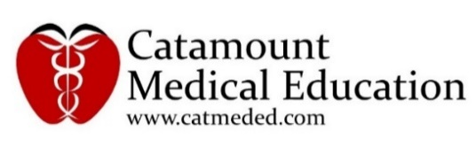
Educational Grant Request
1,800 Seconds™ in Modern Approaches to the Treatment of Advanced Melanoma

Submitted for Consideration to:

September 2016

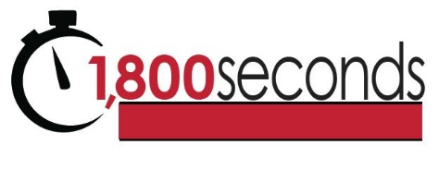

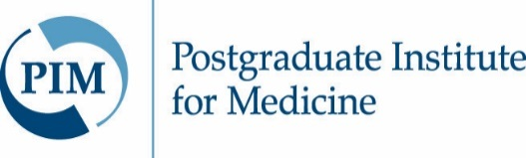
Title | 1,800 Seconds™ in Modern Approaches to the Treatment of Advanced Melanoma
Description | A 30-minute (1,800 seconds) video-based online module designed to provide a practical overview of the most recent evidence related to current approaches in the personalized treatment of advanced melanoma in a user-friendly format designed for the busy clinician. A downloadable podcast will also be made available for those who prefer to listen to the presentation versus watching the video.
Educational Goal | To improve the clinicians’ knowledge and approaches to the personalized management of patients with advanced melanoma.
Date(s) | Expected Release Date: February 2017  Expected Expiration Date: February 2018
Location | Online, CME University and freeCME platforms
Target Audience | Medical oncologists and other healthcare professionals who care for patients with advanced melanoma.
Guaranteed Participation | A minimum of 500 completers, as guaranteed by CME University and freeCME platforms, with total participating learners of 2,000.
Expected Outcomes | Increase in participant knowledge of:  - BRAF-targeted therapies and checkpoint inhibitor immunotherapies for advanced melanoma  - Treatment-specific considerations such as rate of response, potential for long-term survival and toxicity profiles in therapy selection  - Patient considerations such as extent of disease in treatment decisions  - Options for combination therapy for advanced melanoma  - Data and guidelines on dosing and treatment sequencing  Increase in participant confidence or competence in:  - Utilizing treatment specific considerations and patient considerations in personalizing treatment for advanced melanoma patients  - Selecting appropriate combination therapy for select advanced melanoma patients  - Utilizing current data and guidelines in selection of dosing and treatment sequencing for patients with advanced melanoma  Change in participant performance through:  - An improvement in the personalized management of patients with advanced melanoma

Introduction
Advanced melanoma is a life-threatening cancer of the skin that occurs when the most common form of cancer, melanoma, goes untreated. While most patients with early melanoma can be cured, 10-15% of melanoma cases will become advanced. Advanced melanoma is challenging to treat and becomes incurable once it spreads to distant lymph nodes or other areas of the body. Furthermore, the treatment of advanced melanoma has changed in recent years with newer forms of immunotherapy and other targeted therapies that are associated with better outcomes than chemotherapy.
Due to the fact that skin cancer is a common condition in the US, education on the treatment of advanced melanoma is crucial in order to decrease deaths due to melanoma. There is a need to improve clinician knowledge regarding the different advancements in melanoma therapy and clinical trials that are being conducted using combination therapy. Confusion also surrounds the side effects and sequencing of these drugs as well as the clinician’s ability to effectively translate this information to the care of their patients.

The 1,800 Seconds™ activities are designed to provide the most up-to-date information on a clinical topic for busy clinicians in a 30-minute (1,800 seconds) timeframe. Clinicians do not have a significant amount of free time, so the 1,800 Seconds™ series seeks to provide relevant clinical information in the same timeframe it takes to jog 2.5 miles, bike 12 miles, or make dinner. Not only available in video format, each 1,800 Seconds™ activity is available as a podcast download, to be listened to instead of viewed.

Results from two recent 1,800 Seconds™ activities highlight the interest in this format as well as the outcomes that can be achieved through this activity.

1,800 Seconds in Diabetes Management with a GLP-1 Receptor Agonist and Basal Insulin
1,800 Seconds in Overactive Bladder Management

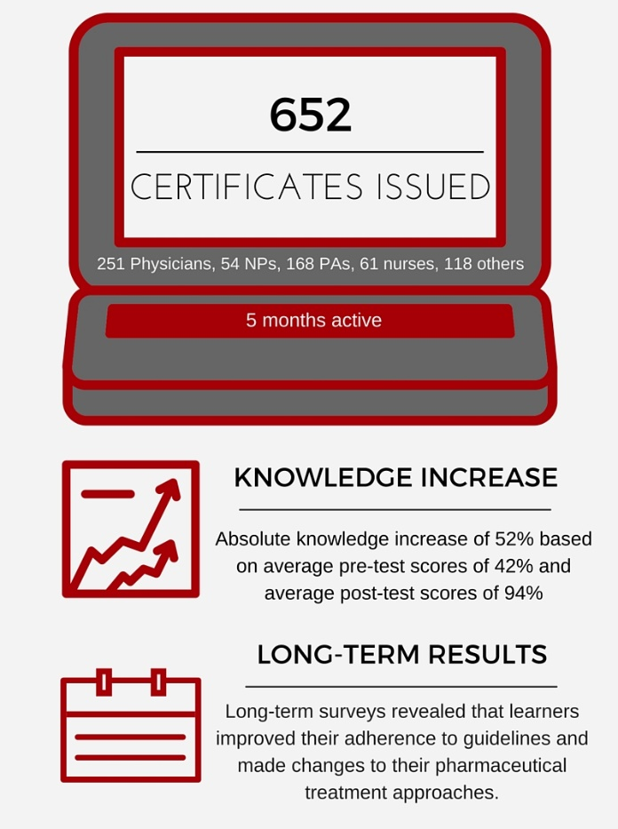
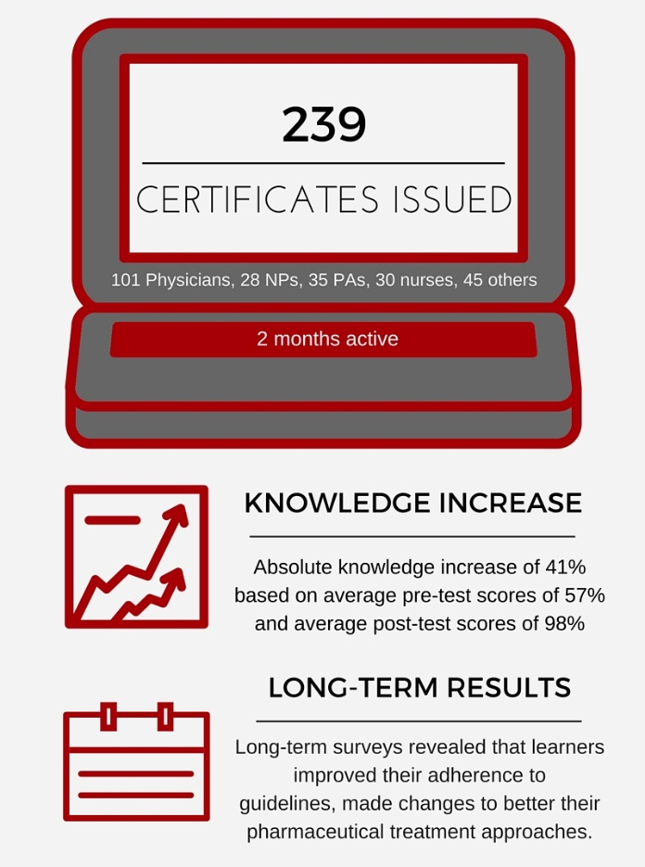

This activity will seek to provide independent, quality education that is based on up-to-date information for healthcare providers that meet the clinical gaps and learning objectives outlined in the following table.

Educational Design
Clinical Gap | Learning Objectives | Outcomes Measures
Clinicians are challenged to implement recent advancements in immunotherapy and targeted therapy for the treatment of advanced melanoma and are therefore missing potential opportunities to provide personalized care to patients. | - Describe BRAF-targeted therapies and checkpoint inhibitor immunotherapies for advanced melanoma | - Measurement of knowledge change based on pre- and post-test questions administered via online  - Identification of competence and confidence through self-report administered via online survey  - Measurement of improved competence and confidence through self-report administered via online long-term survey
 | - Utilize treatment considerations such as rate of response, potential for long-term survival, and toxicity profiles
 | - Discuss patient considerations in treatment
Clinicians’ knowledge of the toxicity, tolerability, and effectiveness of newer combination therapies to treat advanced melanoma is suboptimal. | - Review the various options for combination therapy for advanced melanoma
 | - Identify patient types for the implementation of specific combination therapies
Clinicians’ knowledge and use of sequencing of treatment and applications of clinical guidelines is suboptimal. | - Discuss data and guidelines on dosing and treatment sequencing

Needs Assessment
For a full needs assessment, see Appendix A.

About PIM and Catamount Medical Education
PIM has been providing trusted independent continuing education for healthcare professionals for over thirty (30) years and is a recognized leader for jointly provided continuing education activities. The purpose of the PIM continuing medical education (CME) program is to deliver effective CME activities that are designed to contribute to the professional development of physicians, as well as other healthcare professionals, support their lifelong learning process and positively impact the delivery of medical care. PIM fulfills this mission by forming successful alliances and working in collaboration to deliver impactful educational experiences that are designed to improve patient care practices.

Catamount Medical Education is made up of experienced, award-winning medical education professionals, including an MD-level Medical Director. Working for the past 18 years in the medical education field, the team has worked with some of the most respected experts in adult learning and with clinician thought leaders in their respective fields. Having developed, implemented, and evaluated countless medical education activities, the Catamount team brings a wealth of knowledge and experience to the table when it comes to creating the most effective and meaningful learning experiences for healthcare providers.

Activity Implementation
To implement 1,800 Seconds™ in Modern Approaches to the Treatment of Advanced Melanoma PIM and Catamount Medical Education will ensure that the components outlined below are implemented at the highest level of operational excellence.

Online Video Presentation
1,800 Seconds™ is developed to present 3 key components of the individualized treatment of patients with advanced melanoma in a succinct and clinically relevant format.


Targeted and Immunotherapy
600 seconds
(10 minutes)
Personalized Treatment
600 seconds
(10 minutes)
Combination Therapy
600 seconds
(10 minutes)

Targeted and Immunotherapy



Personalized Treatment

- Review of BRAF-targeted therapies and checkpoint inhibitor immunotherapies

- Putting it all together: Personalizing treatment for patients with advanced melanoma
- Patient selection, dosing and sequencing with BRAF-targeted agents and immunotherapy strategies

Combination Therapy


- Review of combination therapies, including those with BRAF- and MEK-targeted treatments, and checkpoint inhibitor immunotherapies
- Benefits of combination therapy in improved outcomes and management of adverse events

Each component/topic is presented by an expert faculty member who will deliver a video presentation accompanied by supporting slides. As noted above, a downloadable podcast will be made available for those who prefer to listen to the presentation rather than watch the video and slides.

To emphasize the value of the use of online video education, a recent survey of more than 2,000
U.S.-based practicing physicians found that more than 70% have tablets and want video content for learning, and 85% of those physicians take clinical action after watching video online. Of the 85%, 49% changed or made a decision about treatment for a patient, and 40% shared information with a patient.

Planning Teleconferences
To develop the activity content, faculty will be asked to participate in planning teleconferences to develop and refine the information. PIM and Catamount Medical Education will provide content and editorial assistance as needed during the development of the content.

Support Materials
A downloadable handout will be made available upon request by learners that will include the relevant CME information, faculty biographies and disclosures, slides, and any other resources identified by the faculty. To ensure direct impact on patient care, it is important to incorporate practical tools for the healthcare provider (eg, exam room posters, pocket cards, patient education materials) into every educational experience. Faculty will be asked to help identify and/or develop tools appropriate for use by the activity participants in their practice.

Target Audience
The target audience for this activity is medical oncologists and other healthcare professionals who care for patients with advanced melanoma. Guaranteed completers for the activity is 500, with total learners of 2,000.

CME Credit
PIM will certify the activity for AMA PRA Category 1 Credit(s)™. PIM is Accredited with Commendation by the Accreditation Council for Continuing Medical Education (ACCME), the Accreditation Council for Pharmacy Education (ACPE), the American Psychological Association (APA) and is Accredited with Distinction as a provider of continuing nursing education by the American Nurses Credentialing Center’s Commission (ANCC) on Accreditation. PIM is among a very select number of accredited organizations that have demonstrated the highest levels of quality and excellence in the delivery of both continuing physician and nursing education and also meets the qualifications for continuing education credit for MFTs, LPCCs, LEPs and /or LCSWs as required by the California Board of Behavioral Sciences and is an American Dental Association (ADA) CERP Recognized Provider.

PIM is comprised of a staff of dedicated professionals that represent a unique blend of educational, clinical and statistical talent. Eight of these individuals are Certified CME Professionals, and 5 PIM staff members hold clinical degrees, including 1 MD, 2 PharmDs, 1 adult nurse practitioner and 1 mastered prepared registered nurse. The PIM team is rounded out by a biostatistician that holds a master’s degree in public health and is a PhD candidate in health statistics.

PIM would work in joint providership with its designated partner, Catamount Medical Education, a medical education company, to produce this educational offering. PIM, as the accredited provider, will fulfill the requirements to certify the activity for CME credit.

Catamount Medical Education, as joint provider, will be responsible for 1) producing the educational content of the activity at the direction of PIM and the faculty; 2) the layout and design of the materials; 3) production of the materials; and 5) distribution/fulfillment. The overall educational design of the initiative, including faculty selection, will be directed by PIM as per ACCME, AMA and FDA guidelines.
Also, as per ACCME, AMA and FDA regulations, it is understood that supporters will not control the content of the activity. PIM will ensure an unbiased presentation and provide full disclosure of relationships between PIM and supporters and of any significant financial interest or other relationship between faculty and manufacturers of commercial products discussed in the activities. It is understood that any supporter’s funding of this activity is not in any way conditioned upon any present or future business relationship.

Hosting
The hosting of the activity will be on the CME University (www.cmeuniversity.com) and freeCME (www.freeCME.com) platforms, which are dedicated to providing high quality independent CME/CE activities that strive to provide educational offerings that are of the highest quality and value to its members. The online courses are oriented toward clinical practice issues and are designed to assist its members in serving their patient’s healthcare needs. Before participating in a course, learners register on the site and create a unique username and password. The certificate process is fully automated, enabling the learner to complete the activity assessments directly online. Certificates are automatically generated in a print-ready format upon the learner attaining a passing score. Working with the medical community and accredited providers of continuing education, the sites are continuously updated with the latest medical information in a variety of formats, including case studies, streaming video and audio slide presentations.

In 2015, freeCME delivered over 450,000 hours of CME/CE activities and currently offers over 400 hours of CME/CE credit in 20 specialty areas. The platforms membership totaling over 245,000 members is comprised of physicians, nurse practitioners, physician assistants and pharmacists across multiple specialties. In addition to promoting to existing members, email blasts are sent to specialists to notify them of the activity. With over a decade of success, the online platforms rank highest on all major search engines for key medical education search terms, and they stand as the third largest online CME/CE provider.

Announcement Strategy
In addition to announcement and email efforts performed by PIM, additional announcements will be made utilizing the following approaches:
- An announcement on Catamount Medical Education’s CME website
- A strategic announcement campaign through banner ads and journal advertisements

Outcomes
To measure outcomes from the activity the following methods will be used:

Measurable Outcomes | Methods
Increase in participant knowledge of:  - BRAF-targeted therapies and checkpoint inhibitor immunotherapies for advanced melanoma  - Treatment-specific considerations such as rate of response, potential for long-term survival and toxicity profiles in therapy selection  - Patient considerations such as extent of disease in treatment decisions  - Options for combination therapy for advanced melanoma  - Data and guidelines on dosing and treatment sequencing | - Pre- and post-test questions administered via online surveys
Increase in participant competence and confidence in:  - Utilizing treatment specific considerations and patient considerations in personalizing treatment for advanced melanoma patients  - Selecting appropriate combination therapy for select advanced melanoma patients  - Utilizing current data and guidelines in selection of dosing and treatment sequencing for patients with advanced melanoma | - Self-report facilitated via online survey  - Long-term survey responses
Change in participant performance through:  - An improvement in the personalized management of patients with advanced melanoma | - Long-term survey responses

Timeline
Date(s) | Milestone(s)/Deliverable(s)
September 2016 | - Grant requests submitted
November 2016 | - Grant funding secured  - Faculty invited and confirmed
December 2016 | - Faculty development teleconferences occurs  - Content development begins  - Logistics planning for videotaping occurs
January 2017 | - Content finalized  - Videotaping occurs
February 2017 | - Editing and programming for the videos and podcast on the CME University and freeCME platform occurs  - Final reviews and approvals completed  - Posting of activity online and available for 1 year
March 2017 | - Preliminary outcomes delivered upon reconciliation to the supporter with final outcomes delivered after the activity expiration date of February 2018

Conclusion
The implementation of 1,800 Seconds™ in Modern Approaches to the Treatment of Advanced Melanoma will allow for the delivery of timely, valuable, practical information to healthcare professionals who manage patients with advanced melanoma. It is expected that this activity will help to improve healthcare professionals’ ability to better personalize treatment for their patients with the disease through the use of treatment and patient considerations in personalizing therapy, and appropriating implementing combination therapy.

Appendix A—Needs Assessment

Clinical Gap: Clinicians are challenged to implement recent advancements in immunotherapy and targeted therapy for the treatment of advanced melanoma and are therefore missing potential opportunities to provide personalized care to patients.
An improved understanding of cancer pathogenesis has resulted in the development of new treatment options, including targeted agents and immunotherapy. Targeted approaches aim to inhibit molecular pathways that are crucial for tumor growth and maintenance; whereas, immunotherapy endeavors to stimulate a host immune response that effectuates tumor destruction. Targeted therapies and cytotoxic agents also modulate immune responses, which raises the possibility that these treatment strategies might be effectively combined with immunotherapy to improve clinical outcomes.^{,2}
In the past decade, the FDA has approved three major types of immunotherapies. The first type inhibits the CTLA-4 checkpoint molecule and includes ipilimumab which was approved for the treatment of advanced melanoma in 2011.The second type inhibits the interaction between the PD-1 checkpoint and its ligands and includes nivolumab and pembrolizumab. These are typically for patients with a higher risk of recurrence and metastases. The third is a local tumor injection such as talimogene laherparepvec and is utilized among patients with recurrent melanoma. Targeted therapies, common in the treatment of various cancers, are now being applied to melanoma that is positive for the BRAF mutation through the FDA-approved agents cobimetinib, vemurafenib, dabrafenib, and trametinib. About half of all melanoma cases express this BRAF mutation and these drugs prolong survival. There are also immunotherapeutic approaches under clinical investigation such as T-cell checkpoint inhibitors, novel cytokines, therapeutic vaccines, and elimination of immunosuppressive cells. Along with individual drug advancements, testing of combination therapies is underway. Preliminary data are published for the combination of ipilimumab with chemotherapy, radiotherapy, and targeted therapy with BRAF inhibitors that show promising implications for the treatment of advanced melanoma. Some of the benefits of combination therapy include increased antigen expression and improved lymphocyte homing and function. Due to the many recent advances in the treatment of advanced melanoma, education on newer and emerging treatment strategies needs to be available to clinicians.
Clinical Gap: Clinicians’ knowledge of the toxicity, tolerability, and effectiveness of newer combination therapies to treat advanced melanoma is suboptimal.
In a study of 343 clinicians (90% oncologists and 10% dermatologists), when asked about their knowledge of advanced melanoma just under half of the participants rated toxicity and tolerability of treatment as their main concern. Common areas of interest for further education included survival rating, limited treatment effectiveness, low or short patient response, rapid disease progression, and drug resistance. The newest combination of drugs related to the treatment of advanced melanoma, vemurafenib and ipilimumab, target the BRAF mutation in tumor cells and sensitizes the immune system. However, studies have shown that there may be adverse effects that need to be monitored. One study resulted in a higher rate of a grade 3 skin rash that was not responsive to corticosteroids when patients were treated with vemurafenib after progression on ipilimumab than was expected with either of the drugs alone. Another study found a higher rate of hepatotoxicity than had been recorded for either agent alone.³ As for other combinations, a study analyzing the combination of cobimentinib with vemurafenib concluded that the overall progression-free survival was higher than utilizing one of the agents. However, adverse effects included a higher frequency of gastrointestinal events, photosensitivity, elevated aminotransferase levels, and an increased creatinine kinase level than observed with the use of either agent on its own. Similar levels of progression-free survival and an increased quality of life were recorded with the combination of trametinib and dabrafenib but it was noted that adverse effects took longer to notice and required advanced education on the clinician’s part in order to react in an efficient way.
Combining newer agents can improve the functionality of treatment in advanced melanoma, but it may also increase autoimmune toxicities or affect the function of immune suppressive cells such as myeloid-derived suppressor cells and T regulatory cells. Therefore, clinician education needs to be conducted around the benefits and potential side effects that are related to these newer agents.

Clinical Gap: Clinicians’ knowledge and use of sequencing of treatment and applications of clinical guidelines is suboptimal.
Due to the limited amount of data on combination therapies in melanoma, there is a gray area in the knowledge of treatment sequencing. Studies have been conducted that use various dosages and sequencing of treatment in advanced melanoma patients in order to test the most effective dosages for patients. The current recommended practice is to follow FDA guidelines on dosage for each specific drug and to start with targeted therapy drugs before moving onto immunotherapies. Application of clinical guidelines is important, therefore education on the proper guidelines for each new drug is a necessity. In the same study of oncologists assessing the needs of clinicians regarding advanced melanoma, a majority of practitioners noted that there was a strong need for education on the best practices or guidelines for melanoma treatment.⁵ This includes information on dosing schedules, how to effectively monitor patients for adverse reactions and needs for medical intervention.⁴

References:

Cheng R, Cooper A, Kench J, et al. Ipilimumab-induced toxicities and the gastroenterologist. Journal of Gastroenterology and Hepatology. 2015; 30: 657-666
http://www.cancer.org/cancer/skincancer-melanoma/detailedguide/melanoma-skin-cancer-treating-by-stage. Accessed July 1, 2016.
Ventola CL. Mobile devices and apps for health care professionals: uses and benefits. PT. 2014;39(5):356-364.
Vanneman M, Dranoff G. Combining immunotherapy and targeted therapies in cancer treatment. Nature Reviews Cancer. 12, 237-251 (April 2012).
https://www.melanoma.org/understand-melanoma/melanoma-treatment. Accessed June 23, 2016.
Antonia S, Larkin J, Ascierto P. Immuno-oncology Combinations: A Review of Clinical Experience and Future Prospects. Clinical Cancer Research. 2014 Dec; 20(24): 6258-6268.
Hu-Lieskovan S, Robert L, Moreno B, Ribas A. Combining Targeted Therapy With Immunotherapy in BRAF-Mutant Melanoma: Promise and Challenges. Journal of Clinical Oncology. 2014 Jul; 32(21): 2248-2254.
Jones C, Clapton G, Zhao Z, et al. Unmet clinical needs in the management of advanced melanoma: findings from a survey of oncologists. European Journal of Cancer Care. 2015 Jun; 24: 867-872.
Peuvrel L, Quereux G, Saint-Jean M, et al. Profile of vemurafenib-induced severe skin toxicities. European Academy of Dermatology and Venerology. 2015 Sept; 30: 250-257.
Larkin J, Ascierto P, Dreno B, et al. Combined Vemurafenib and Cobimetinib in BRAF-Mutated Melanoma. The New England Journal of Medicine. 2014 Nov; 371(20): 1867-1876.
Lindsay J, Barras M. Facing the challenges of new melanoma-targeted therapies: Treatment of severe fevers associated with dabrafenib/trametinib combination therapy. Journal of Oncology Pharmacy Practice. 2015; 21(4): 293-295.
Kim T, Amaria R, Spencer C, et al. Combining targeted therapy and immune checkpoint inhibitors in the treatment of metastatic melanoma. Cancer Biol Med 2014; 11: 237-246.

